The installation instruction of WE-G0140-A4 & A5 W204 07-ON Sedan/Estate/Coupe
(C63 look & BRA style grille)
- The following parts are included in the kit (Item a ~ item f):
ITEM | PARTS
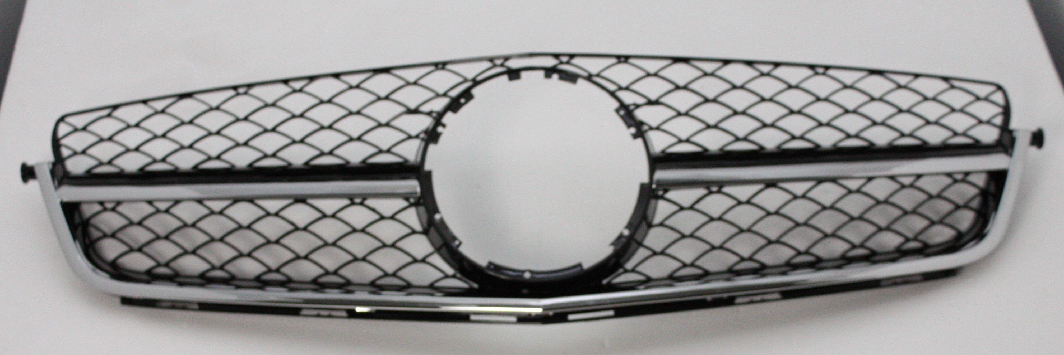  (A) WE-G0140-A4 | 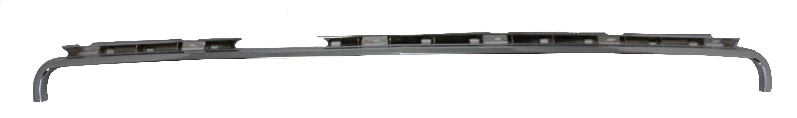  (a) bonnet molding frame x 1pcs |  | .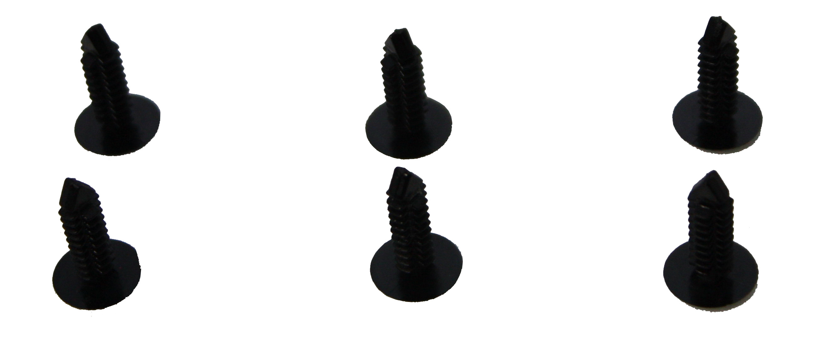  (b) tree rivet x 6pcs
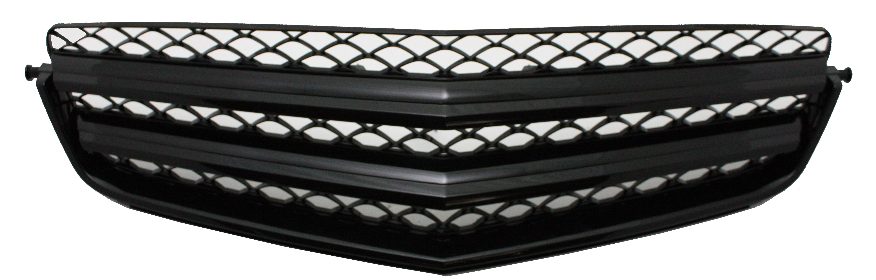  (B) WE-G0140-A5 | 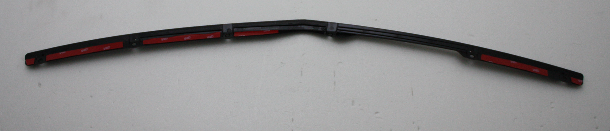  (c) bonnet molding support x 1pcs |  | 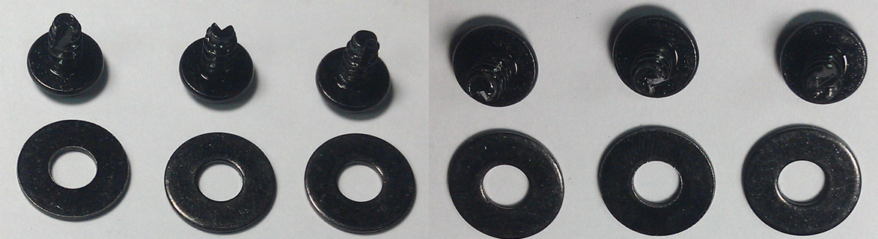  (d) screw & washer x6 sets for “c” parts
 | 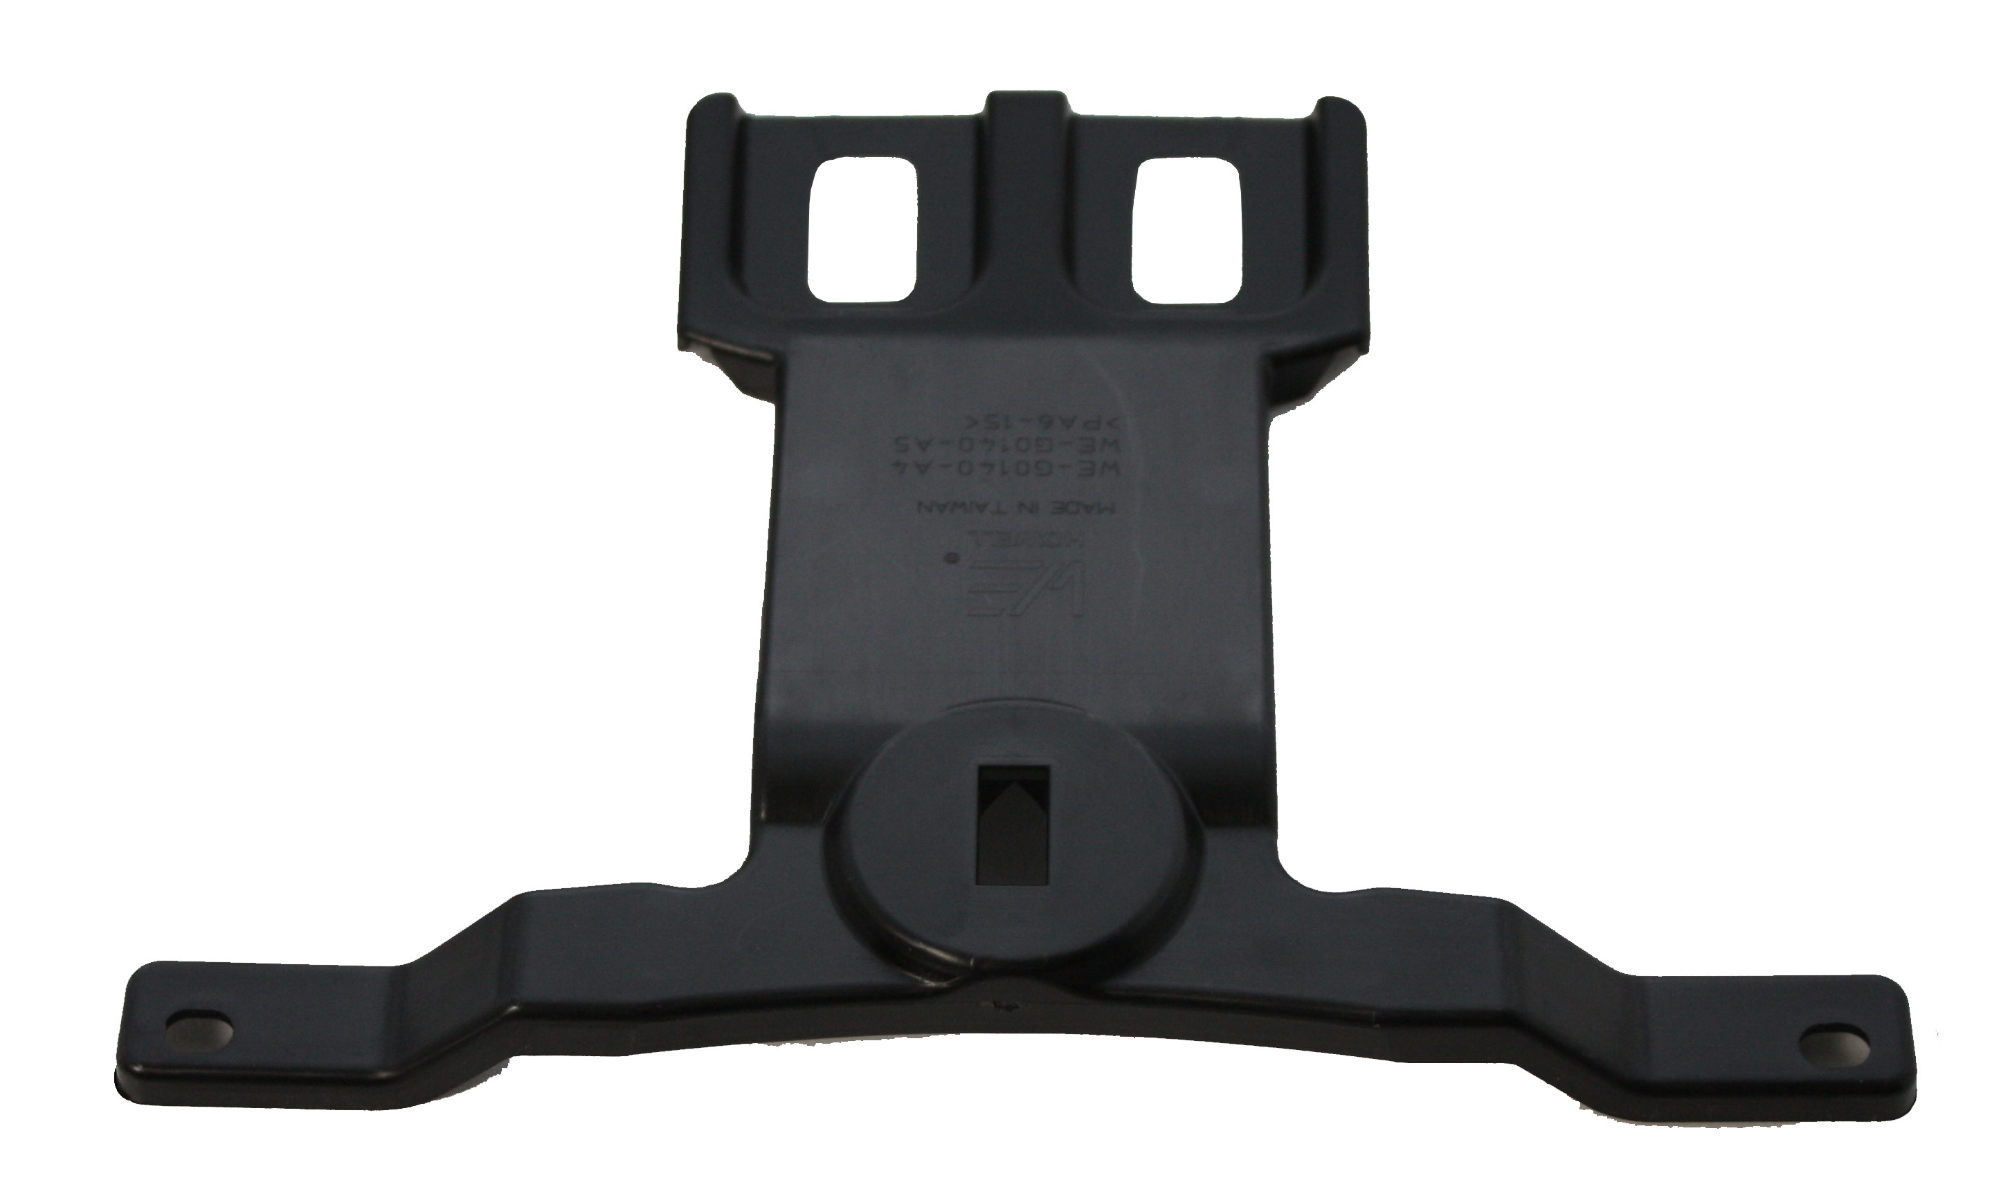  (e) grille support x 1pcs | 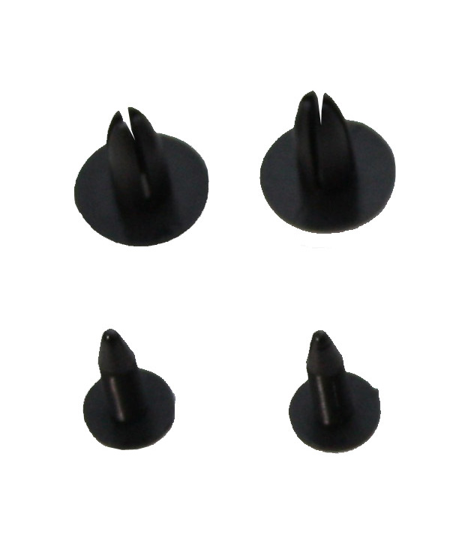  (f) grille support clip x 2 sets

- Remove the original grille and grille support from the front bumper.
- Install the grille support (e) onto the grille (A) or (B) with the grille support clip (f) then it will be completed as
below picture (g) grille WE-G0140-A4 or A5
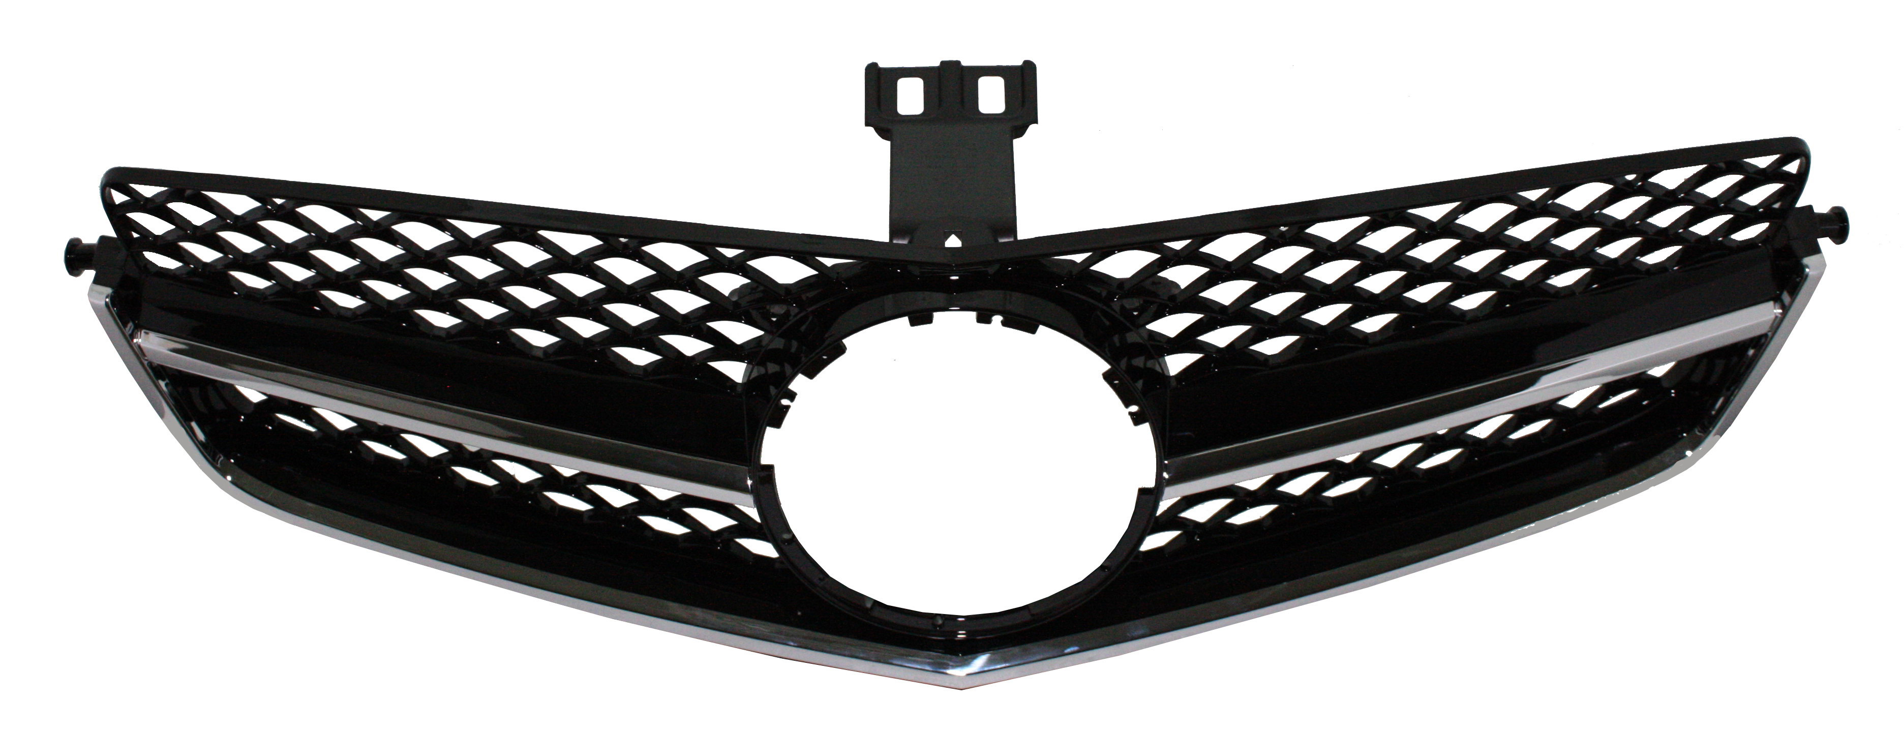  (g) | 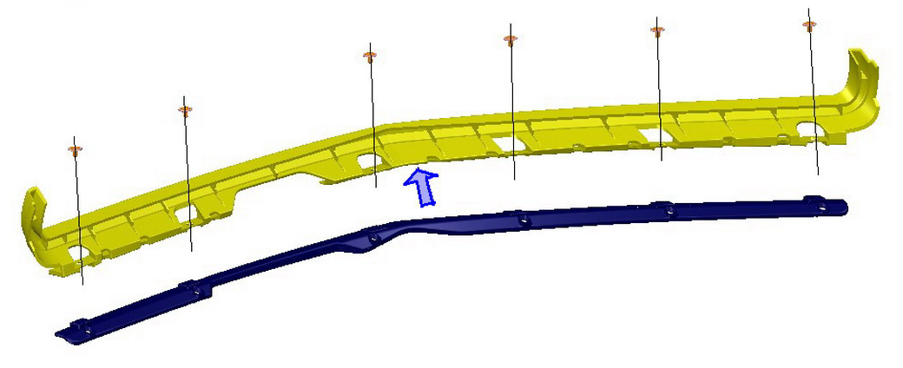  (h) | 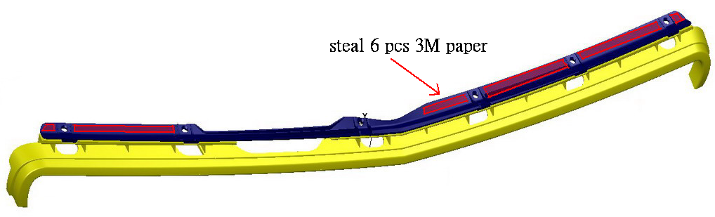  (j)
 | 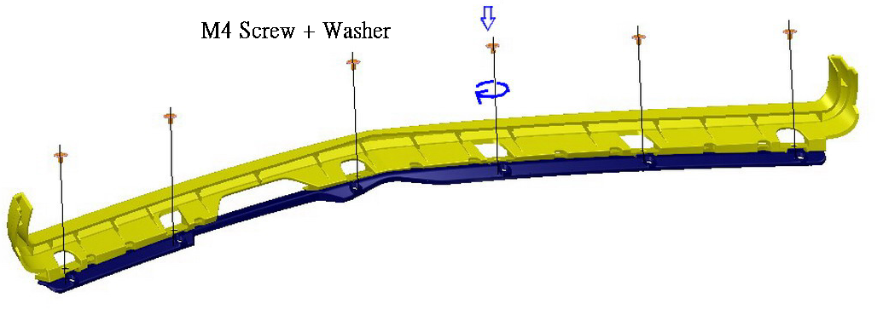  (i) | 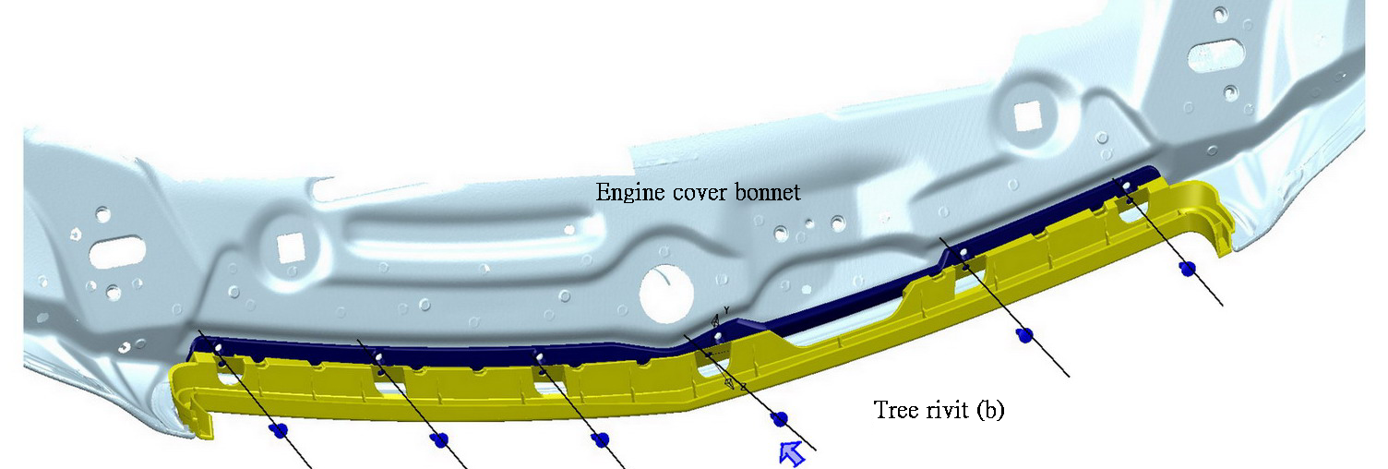 (k)
4. Install the above grille onto the car front bumper.
5. The installation of bonnet molding : ‘07-‘11 model please refer point A and ‘12- ON please refer point B
A. Remove the rubber seal from the bonnet and clean the bottom edge of the bonnet. Peel the plastic paper of 3M tape on the bonnet molding frame (a) and stick it onto the correct position of the bonnet then fit it with 6 pieces of the
tree rivet (b).
B. Firstly to peel the plastic paper of 3M tape on the bonnet molding frame (a) and stick it onto the bonnet molding support (c) and use screws + washer (d) to screw (a) and (c) together. Please refer picture (h) & picture (i).
Then remove the rubber seal from the bonnet and clean the bottom edge of the bonnet. Peel the plastic paper of 3M tape on the bonnet molding support (c) and stick the bonnet molding frame ( a + c = j ) onto the correct position of
The bonnet then fit with 6 pieces of tree rivet (b). Please refer picture (j) & picture (k).
6. Now the grille installation is complete.

